**Middle East Technical University**

**Northern Cyprus Campus**



**Petroleum and Natural Gas Engineering**

**PNGE 321 – PROJECT TECHNICAL REPORT**

**HYDRAULIC LOSSES AND CUTTING TRANSPORT**

**Name:** Muhammad Ammar Shahzad

**Student #** 2049062

**Submitted to:** Prof. Dr. Doruk Alp

**Submission date:** 13/1/2020

# INTRODUCTION

The frictional pressure loss term (DPf) in the energy balance equation is the most difficult to evaluate and it is important because extremely large viscous forces must be overcome to move drilling fluid through the long slender conductor used in the rotary drilling process.

The rheological models used by drilling engineers to approximate the fluid flow behavior are

* Newtonian model (For water, gases and high gravity oils)
* Bingham plastic model
* Power law model

# rheological models ile ilgili görsel sonucuRheological models

Figure 1: Rheological models

In order to determine the type of model we have, we plot shear stress Vs shear rate.

## Newtonian fluids

In case of Newtonian fluids, we get a straight line on the plot starting from origin. The equation of the line becomes

$$τ= μγ$$

This linear relation between $τ$ and $γ$ is only valid as long as the fluids flows in laminar flow. At higher shear rates, the flow rate changes from laminar to turbulent flow.

## Non-Newtonian fluids

Bingham plastic model does not flow until the applied stress exceeds the yield point which is the minimum value of $τy$. It ends up being a straight line starting at $γ=0.$ The equation of the line is

$$τ=μp*γ+τy$$

### Pressure loss calculations

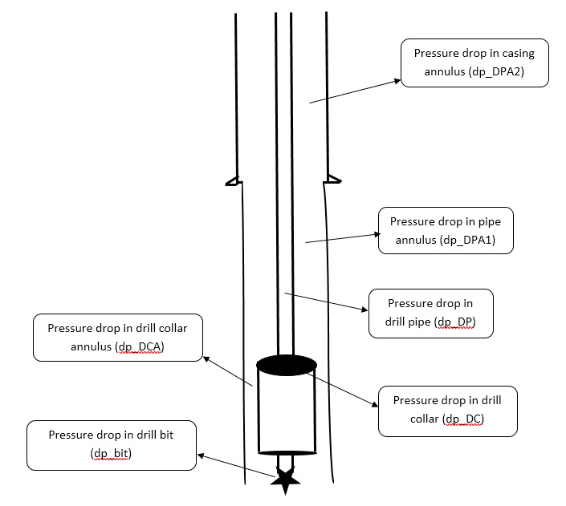The figure below shows the pressure losses we are going to find using these models.

There are a total of six regions where there are significant pressure losses.

* Pressure loss in the drill pipe
* Pressure loss in the drill collar
* Pressure loss in the drill bit
* Pressure loss in the drill collar annulus
* Pressure loss in the drill pipe annulus
* Pressure loss in the casing annulus area

For any rheological model, after identifying the type of model, we first calculate the mean velocity parameter for drill pipe, drill collar, and the sections of the annulus which are drill pipe annulus, drill collar annulus and casing annulus region. The mean velocity is directly proportional to the flowrate that means for every change in the flowrate, our velocity for each region in wellbore would be different.

After velocity calculations, for Bingham plastic model, we carry on to the flow behavior parameters which include the plastic viscosity and the Tao yield. The plastic viscosity is taken from the straight line of N vs $∅$ plot at $∅=600$ and $∅=300$.

However, for power law model, we calculate two parameter, n and K. The parameter ‘K’ is usually called the consistency index of the fluid and parameter ‘n’ is called power law exponent or flow behavior index.

Now, to determine the turbulence criteria, it could be found either with critical velocity criterion or with Reynolds number criterion. I opted for the later. For Bingham plastic model, we calculate our Hedstrom number and from critical Reynolds number plot for Bingham plastic fluids, we read our critical Reynolds number using the Hedstrom number. The Reynolds number is then calculated and if the actual Reynolds number is greater than the critical Reynolds number, we have turbulent flow, otherwise it is laminar flow.

For power law model, the critical Reynolds number is read from Fig. 4.34 (Friction factors for power law fluids) using the value of ‘n’.

After determining the turbulence criteria, we use the appropriate equations for pressure losses depending on whether it is turbulent or laminar flow.

The fanning friction factor for Bingham plastic model was calculated using Jain’s equation which gives us the moody friction factor, which we divide by 4 to obtain fanning friction factor. Whereas for power law, I had to use the iterative procedure because the equation is non-linear.

$sqrt\left(\frac{1}{f}\right)=\left(\frac{4}{n^{0.75}}\right)Log\left(Nre*f^{1-\frac{n}{2}} \right)-(0.395/n^{1.2}$)

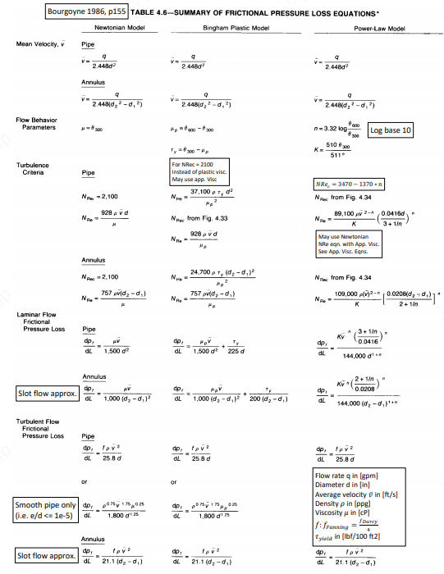The following table shows the equations for each parameter for all three rheological models.

The pressure loss at the drill bit is calculated using

$$DPbit=\frac{8.311*{10}^{-5} ρq^{2}}{cd^{2}At^{2}}$$

Where Cd is assumed to be 0.95 and ‘At’ is the area nozzle area.

For three cone roller bit 15-12-15

$$At=\frac{pi}{4} \left({\left(\frac{15}{32}\right)}^{2}+{\left(\frac{12}{32}\right)}^{2}+{\left(\frac{15}{32}\right)}^{2}\right)=0.4556 in^{2}$$

### Coding for Bingham plastic model

Using the given data we were provided in the class activity for Bingham plastic model, I wrote a code to calculate the pressure losses, velocity of cuttings, the concentrations and the density of mud using MATLAB.

The flowchart on the following page explains the algorithm of the Bingham plastic code.

### Plots for Bingham plastic model

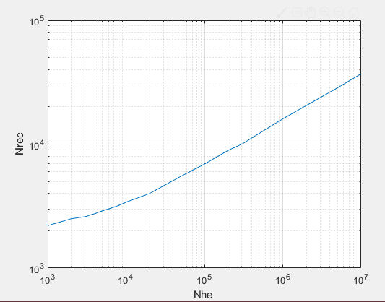

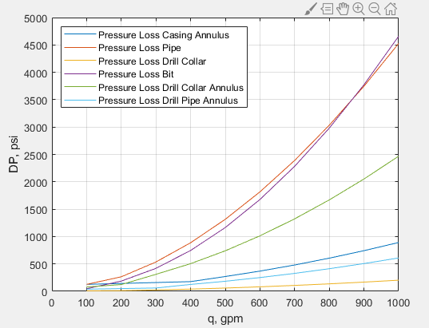The plot for Nhe Vs Nrec made on MATLAB using interpolation function.

The pressure losses at drill pipe, drill collar, drill bit, drill collar annulus, drill pipe annulus and casing annulus at different values of flowrate. As we can see from the plot, the pressure loss in the drill pipe and drill bit are the highest. The flow in the drill pipe and drill collar is mostly turbulent except at lower flowrates, in which case its laminar. Whereas in annular sections, its mostly laminar except at higher flowrate values like 300-400 gpm in case of this example. If we zoom in the graph, you can clearly see the transition where the laminar flow ends and turbulent flow starts because the pressure loss has a sudden increase when turbulent flow begins.

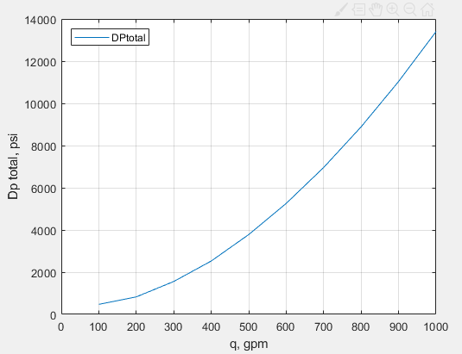flowrate vs total pressure loss. The pressure loss keeps increasing with the increasing flowrate.

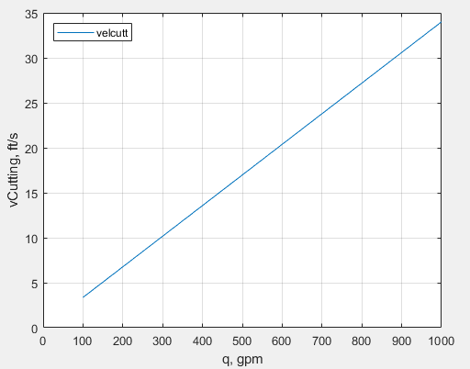

As we increase the flowrate, the cuttings velocity increase linearly.

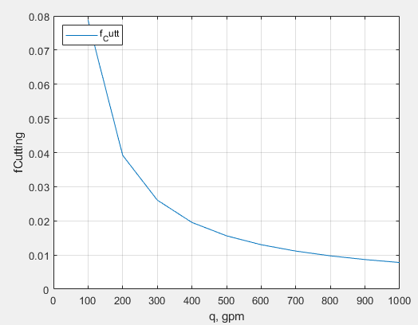

The concentration of the cutting decrease with increasing flowrate.

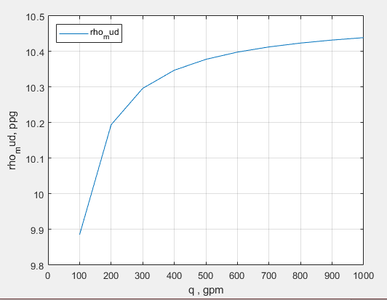As we increase the flowrate, we are taking more rock cuttings from the annulus area and the density of the mud increases.

### Coding for Power law model

### Plots for Power law model

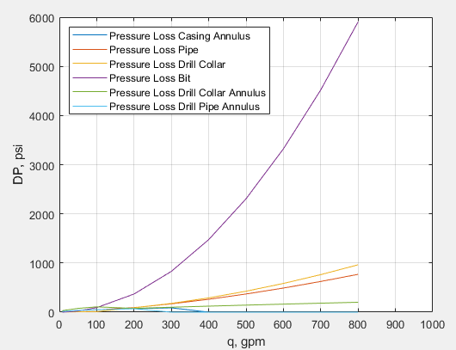

For power law code, my plot for pressure losses did not come out how I expected it to be. Basically, until laminar flow region, it should follow the power law exponential curve shape and then it increases with the increasing flowrate but for my plots for drill pipe annulus and casing annulus, they increase until laminar and then suddenly drop to zero, which could be because of a problem in the iterative procedure for fanning friction factor.

